Vacancy: Member of the MRCP(UK) Part 1 Examining Board
The Federation of Royal Colleges of Physicians of the UK is seeking to appoint one new member to the MRCP(UK) Part 1 Examining Board. We are looking to appoint a Nephrology representative.

The successful applicant will assist the Chair and Medical Secretary in the running of the Part 1 Examination to ensure that all academic objectives and standards set by the General Medical Council are met; attend meetings of the Board three times per year, convened to set examination papers; review candidate performance in the most recent diet; assist with the development of the Part 1 Examination; act on the advice of the MRCP(UK) Management and Policy Board and Examining Boards on policy and academic matters relating to the Examinations; and support MRCP(UK) Central Office on the delivery of the Examinations.

A full list of the post’s responsibilities is set out in: The Responsibilities and Duties of Members of the Part 1, Part 2 and Speciality Certificate Examining Boards. In addition a copy of the remit and responsibilities of the examining board can be found on the MRCP(UK) website.

Applicants should meet the following criteria to be eligible to apply:
- hold the MRCP(UK) or an equivalent postgraduate diploma
- be practising as a specialist in nephrology, and a member or fellow of one of the three Colleges
- be registered with a licence to practise and in good standing on the GMC specialist register
- be actively engaged in the training of junior doctors in the UK (or within the last two years)
- be up-to-date as appropriate with relevant national guidelines, CPD requirements, employer’s equality and diversity training and appraisal process

This is a non-salaried position though applicants should note all reasonable expenses and travel costs will be met by MRCP(UK) Central Office in line with the Federation expenses policy.
The tenure of board appointments is five years. This is subject to regular attendance at meetings and remaining in good standing with the GMC as these will be monitored.
Applications for the post should be submitted to policy.officer@mrcpuk.org by 26th July 2019. This should include the following documents:
- CV – including contact details, current position, GMC number and College membership;
- Covering letter – outlining your suitability for the role and demonstrating how you meet the eligibility criteria outlined above.

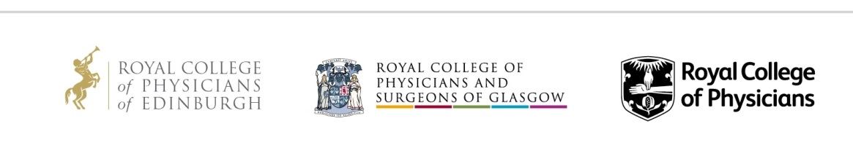
Successful applicants are strongly encouraged to attend the meeting of the MRCP(UK) Part 1 Examining Board takes place on 19th and 20th November 2019 at the Royal College of Physicians of London to observe. They would then formally take up their positions on the Board at the meeting on 5th and 6th February at the Royal College of Physicians of Edinburgh.

